Geometry

Line-Segment, Ray and Line

Definition of in Line-segment, ray and line geometry:
The part of a line is called a line-segment as shown below.
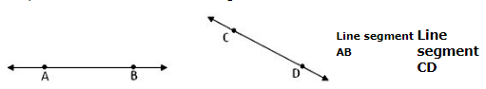
Only one line can be drawn passing through any two points but a number of lines can be drawn through a point.
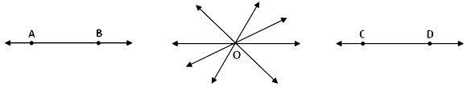
Line AB | Lines passing through a point O Line segment CD
Ray: We know about sun-rays. A sun-ray starts from the sun and goes on a direction up to endless space. Similarly a geometrical ray is considered a special kind of line which starts from a fixed point and goes to any distance to the other direction of the starting point.
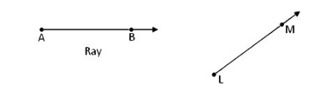
Distinction between line-segment, ray and line:
Line-segment  1. It has two end points.  2. The length of a line-segment is definite. So, it can be measured.  3. The symbol of a line-segment is _____ | Ray  1. Ray has one starting point and another near the arrowhead.  2. It has a starting point but no other end point. So, its length cannot be measured.  3. The symbol of a ray is → |  | Line  1. There are no end points in a line.  2. There are no end points. So, length of a line cannot be measured.  3. The symbol of a line is ↔

